Dipak Debnath Arka

20301066

Sec: 08

**NS3**

128:

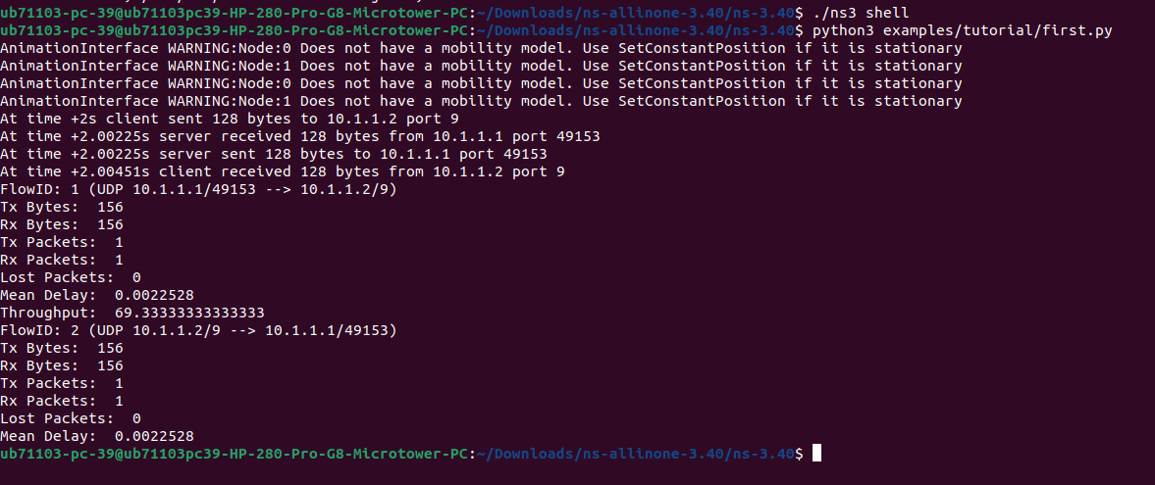

256:

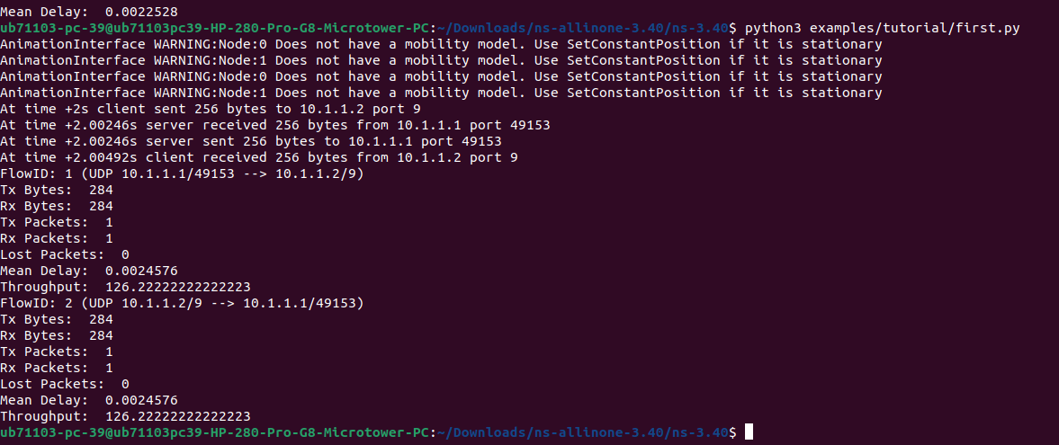

512:

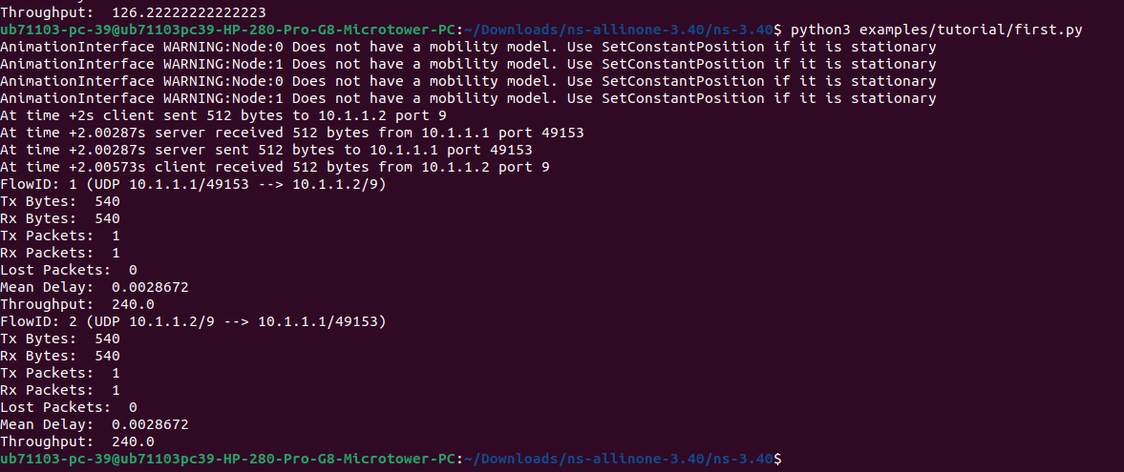

1024:

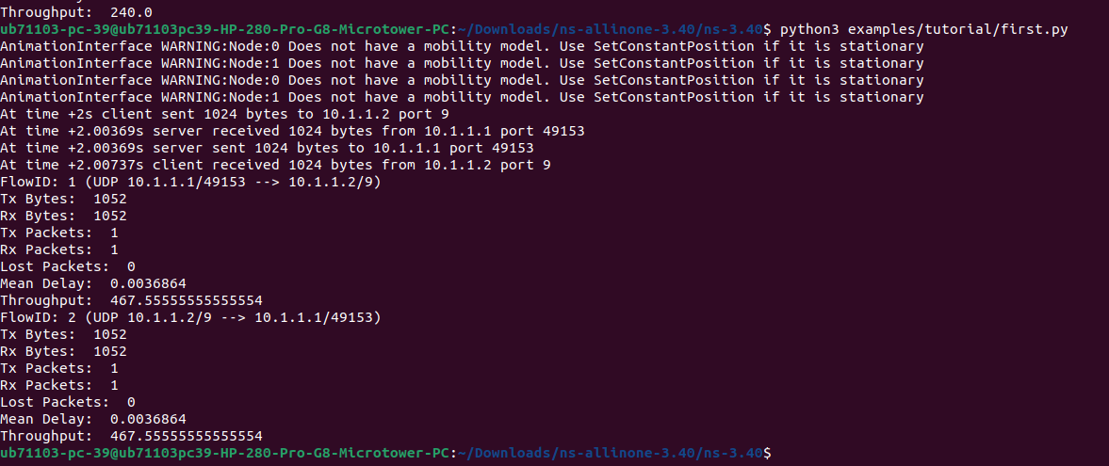

2048:

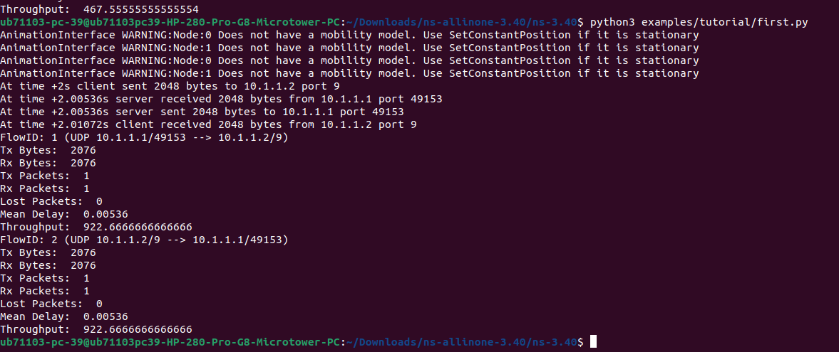

Table:

| Packet Data Size | Throughput |
| --- | --- |
| 128 | 69.33333333333333 |
| 256 | 126.22222222222223 |
| 512 | 240.0 |
| 1024 | 467.55555555555554 |
| 2048 | 922.6666666666666 |

Graph:

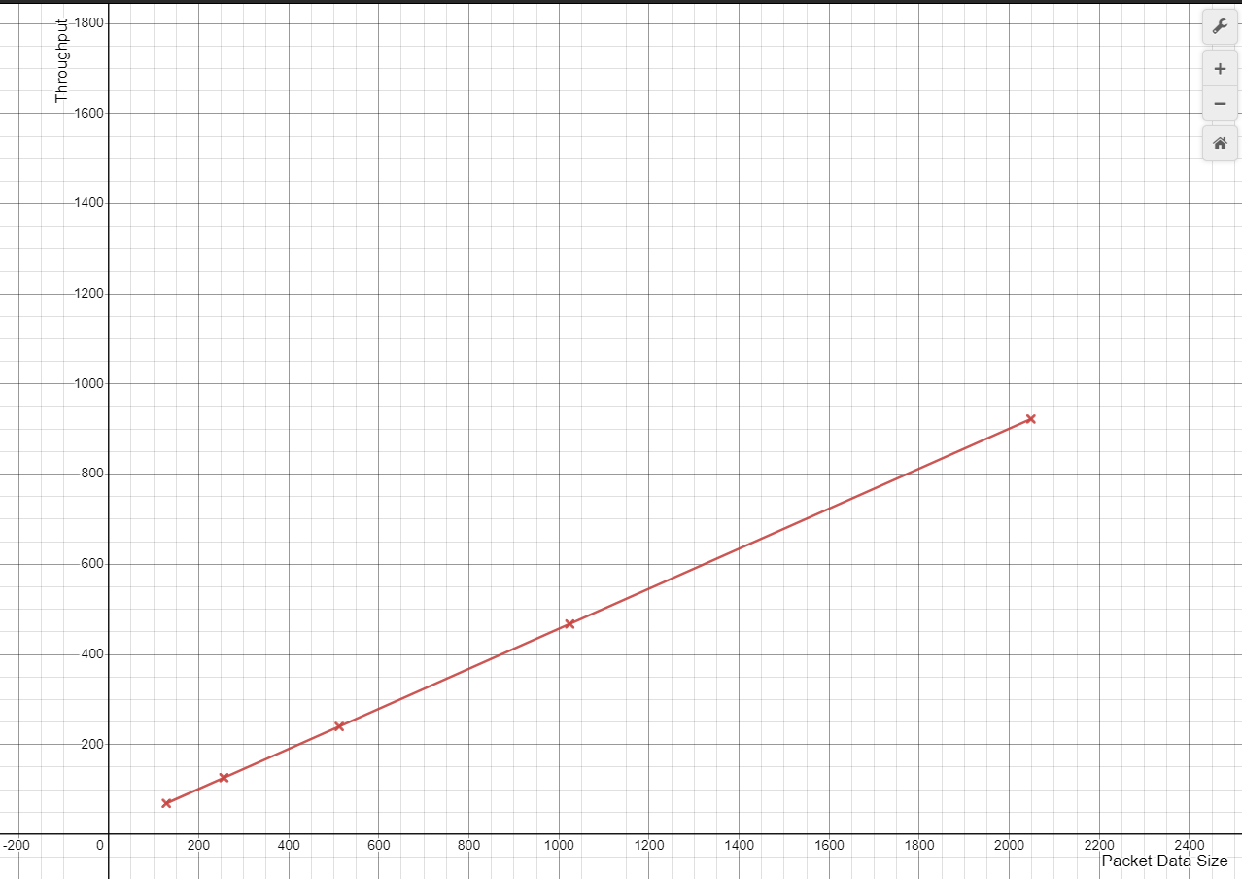

Figure: Packet Data Size vs Throughput

Here, X-axis is the Packet Data Size ranging 128 to 2048. Y-axis is the Throughput. The graph shows that the line is upward. The packet data sizes are 128, 256, 512, 1024, 2048 and the throughput values are 69.33333333333333 ,126.22222222222223, 240.0, 467.55555555555554. 922.6666666666666. It clearly shows that If the packet size is increasing the throughput value is also increasing.